NATIONAL UNIVERSITY OF SCIENCES AND TECHNLOGY

(DEPARTMENT OF MECHANICAL ENGINEERING)

FUNDAMENTALS OF PROGRAMMING

NAME: SYED ALI NAQI

ID: 466889

SECTION: B

**TASK 1:**

#include <iostream>

using namespace std;

int main(){

int number;

cout<<"enter a positive integer:"<<endl;

cin>>number;

cout<<"factors of"<<number<<"are:"<<endl;

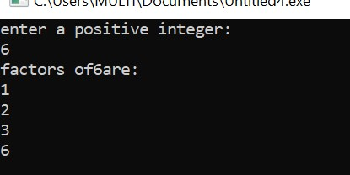 for(int f= 1; f<=number; ++f){

if(number %f== 0){

cout<<f<<endl;

}

}

return 0;

}

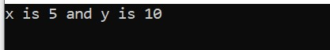

**TASK 2:**

**TASK 3:**

#include <iostream>

using namespace std;

int main(){

//

int integralvalue;

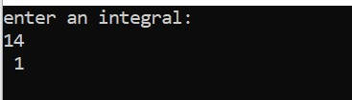cout<<"enter an integral:"<<endl;

cin>>integralvalue;

int result;

if(integralvalue >10&&integralvalue <= 20 ){

cout << " 1"<<endl;

}else{cout <<" 0"<<endl;

}

return 0;

}

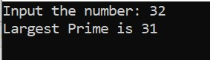**TASK 4:**

#include <iostream>

using namespace std;

int main(){

int num, i;

bool value;

cout<<"Input the number: ";

cin>>num;

while (num>=2){

i=2;

value=false;

while(i<num){

if(num%i==0){

value=true;

break;

}

i++;

}

if(value==false){

cout<<"Largest Prime is "<<num<<endl;

break;

}

num--;

}

return 0;

}

**Task 5 (a)**

#include <iostream>

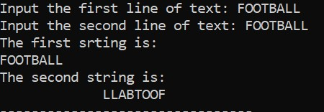#include <limits>

using namespace std;

int main(){

char a[25], b[25];

cout<<"Input the first line of text: ";

cin.get(a, 25);

cin.ignore(numeric_limits<streamsize>::max(), '\n');

cout<<"Input the second line of text: ";

cin.get(b, 25);

cout<<"The first srting is: \n"<<a<<endl;

cout<<"The second string is: \n";

for (int i=24; i>=0; i--){

if (a[i]==b[i]){

cout<<b[i];

}

}

return 0;

}

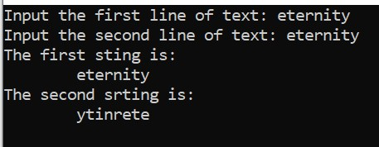**Task 5(b)**

#include <iostream>

#include <string>

using namespace std;

int main(){

string a, b;

int l;

cout<<"Input the first line of text: ";

getline(cin, a);

cout<<"Input the second line of text: ";

getline(cin, b);

if (a==b){

l=a.length();

for (int i=0; i<l/2; i++){

swap(b[i], b[l-i-1]);

}

}

cout<<"The first sting is: \n\t"<<a<<endl;

cout<<"The second srting is: \n\t"<<b<<endl;

return 0;

}

**Task 6**

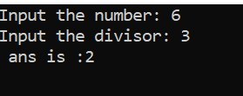#include <iostream>

using namespace std;

int main(){

int num, divisor, ans;

cout<<"Input the number: ";

cin>>num;

cout<<"Input the divisor: ";

cin>>divisor;

if( num< divisor){

cout<<" division is not possible ."<<endl;

}else{

cout <<" ans is :"<<num/divisor<<endl;

}

return 0;

}

**Task 7**

#include <iostream>

#include <string>

using namespace std;

int main(){

string a;

int l;

cout<<"Input the string text: ";

getline(cin, a);

l= a.length();

for (int i=0; i<=l; i++){

for (int j=0; j<=l; j++){

if (tolower(a[i])==tolower(a[j]) && i!=j){

a.erase(j, 1);

j--;

l=a.length();

}

}

}

cout<<a;

return 0;

}

**Task 8**

#include <iostream>

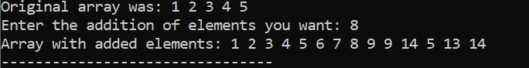using namespace std;

int main(){

int n,a[5]={1,2,3,4,5};

cout<<"Original array was: ";

for (int i=0;i<5; i++) {

cout<<a[i]<<" ";

}

cout<<endl;

cout<<"Enter the addition of elements you want: ";

cin>>n;

for (int i=5;i<5+n;i++) {

a[i]=i+1;

}

cout<<"Array with added elements: ";

for (int i=0;i<5+n;i++) {

cout<<a[i]<<" ";

}

return 0;

}

**Task 9**

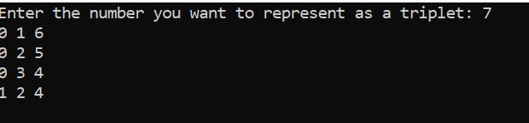int main() {

int X;

cout << "Enter the number you want to represent as a triplet: "; cin >> X;

for (int i=0; i<=X; i++) {

for (int j=i+1;j<=X;j++) {

for (int k=j+1;k<=X;k++) {

int a[3]={i,j,k};

int sum=a[0]+a[1]+a[2];

if (sum==X) {

cout<<a[0]<<" "<<a[1]<<" "<<a[2]<<endl;

}

}

}

}

return 0;

}

**Task 10**

# include <iostream>

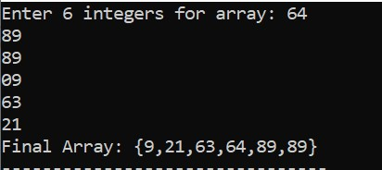using namespace std;

int main (){

int temp, len = 6, arr[len];

cout<<"Enter "<<len<<" integers for array: ";

for (int i = 0; i<len; i++) {

cin>>arr[i];

}

for (int j = 0; j<(len-1); j++) {

for (int i = 0; i<(len-1); i++) {

if (arr[i]>arr[i+1]) {

temp = arr[i];

arr[i] = arr[i+1];

arr[i+1] = temp;

}

}

}

cout<<"Final Array: {";

for (int i = 0; i<len; i++) {

cout<<arr[i];

if (i == len-1)

continue;

cout<<",";

}

cout<<"}";

return 0;

}